CamSTAR - Peer Activity

Complete 1 – 4 BEFORE CLASS

Watch this video in Section 3
Link to video: How to Answer “Behaviour-based Interview Questions”

Familiarize yourself with the ten professional skills employers want graduates to have.
Link to: Review Section 2.3 Understanding Professional Skills & Behaviours

Once you have reviewed the ten professional skills complete the self-assessment. For some of you this will be the first time you have thought about yourself as someone with professional skills. If this is confusing for you please consult with your instructor and/or a mentor for assistance.
Link to: Section 2.4 Self Assessment of Professional Skills

Choose one professional skill from each of the Skills Sections (e.g. personal, interpersonal etc.) for a total of four (4):
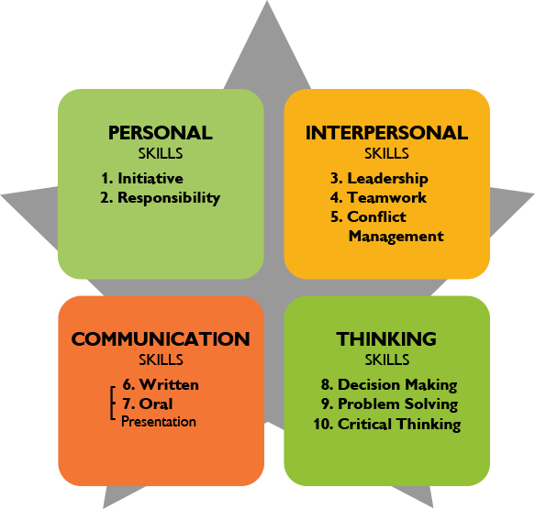

IN CLASS: Complete one STAR story in class for peer review. For example: Personal Skills, Initiative.
LINK TO: SECTION 4.2 ACTIVITY: USE THE STAR STORY TOOL

Enter the STAR story into your STAR Story Template .

Complete three more STAR stories on your own (it’s fine to have someone review it but you will not have class time for these ones).

The peer review rubric and the STAR story table or slide show has examples of complete STAR stories for your reference.

