CamSTAR – Quick Start Guide

this Guide highlights some of the tools that will prepare you to excel during your next interview. If you have any questions about skills you are learning in your courses talk with one of your instructors, or contact the good folks at Career Services.

Start here! This six minute video tells you why STAR stories are important.
LINK TO: 3.2 VIDEO: THE STAR STORY TECHNIQUE

Familiarize yourself with the ten professional skills employers want you to have.
Link to: Review Section 2.3 Understanding Professional Skills & Behaviours

The links below have examples of complete STAR stories for your reference.
link to: Table of Professional Skills and Behaviours (see materials tab) and slide shows (sections 3.3 & 3.4)

Once you have reviewed the ten professional skills have a look at the self-assessment. For some of you this will be the first time you have thought of yourself as someone with professional skills. If this is confusing for you please consult with career services, an instructor and/or a mentor for assistance.
Link to: Section 2.4 Self Assessment of Professional Skills

Which one of the professional skills do you have a STAR story about? We recommend choosing one from each of the Skills Sections (e.g. personal, interpersonal etc.) for a total of four (4):
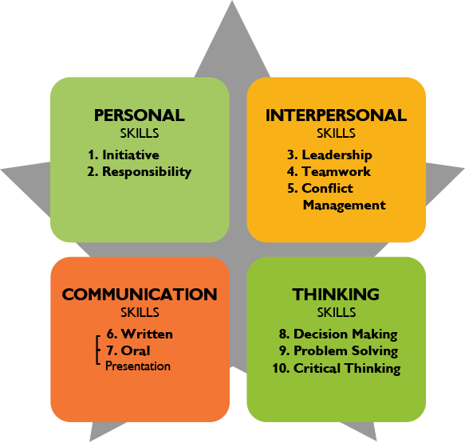

START WITH ONE: Complete one STAR story, share it with a friend or call Career Services to review and provide feedback. For example: Personal Skills, Initiative.
LINK TO: SECTION 4.2 ACTIVITY: USE THE STAR STORY TOOL

Enter the completed/edited STAR story into your STAR Reflective Story File Template .

Once you have completed the above activities you will have a solid start in preparation for any interview whether it be for a summer job or work experience position, an interview to get into a university program or one that begins your career in the field of your choice.

CamSTAR works on your mobile phone or tablet so you can draft STAR stories when you’ve had an opportunity to demonstrate a skill in class, or in the work place.

